

Connecticut Literacy Leadership Training Series

HILL for Literacy, Inc.
http://www.HILLforLiteracy.org

September 2016

Agenda

9:00 – 9:15 Welcome and Introductions
- Expected Outcomes

9:15 – 10:00 Survey Results

10:00-10:30 School Literacy Plan SY16-17 and Timeline
- Review Priority Goals and Activities
- Carousel Brainstorm Activity
- Confirming or Developing the Activity Timeline SY16-17

10:30 – 10:45 Break

10:45- 11:30 Managing Change
- Fire and Water Activity
- Stages of Concern

11:30 – 12:30 Lunch

12:30 – 1:15 Tools to Support Implementation
- Managing the Literacy Block
- Planning for Instruction-Whole Group/Small Group Templates

1:15 – 1:45 Measuring Implementation
- Purpose and Types of Measurement Tools
- Review Example Tools

1:45--2:00 Wrap-up and Next Steps
- Training Evaluation

“Management is doing things right; leadership is doing the right things.”
-Peter Drucker

Expected Outcomes:

- Project Survey Results
- Literacy Plan Carousel Activity
- Build/Confirm Timeline for SY16-17
- Managing Change
- Tools to Support Implementation
- Measuring Implementation

Materials Packet:

Participants should have:

- PowerPoint presentation and handout packet (electronically or printed)
- Computer or Tablet
- School Literacy Plan and Timeline for SY16-17

Literacy Leadership Series SY16-17
Follow-up Support for Cohort 1& 2 AD Schools (Returning Schools)
LEADERSHIP RETREATS

Each school team of school leaders that participated in the literacy leadership series during SY15-16 will be attend 3 literacy leadership retreats. The team of 6 should represent the following departments/groups: principal, literacy facilitator/coach, one regular education teacher from grades K, 1st 2nd or 3rd, one Special Education teacher, one ELL teacher (if applies), district level curriculum or literacy coordinator. Each school can send the same team as last year or designate new members if deemed appropriate.

Location: Institute of Technology and Business Development (ITBD) Time: 9:00-2:00
185 Main Street, New Britain, CT 06051 Room 313

Dates: 9/29, 4/6, 6/1

Retreat Logistics
An email reminder/RSVP will be sent to each team member. It is the responsibility of each team member to download handouts for sessions. As session materials will be shared via electronic file sharing systems (e.g. DropBox, FlashDrives, Web) participants are invited to print materials if hard copies are preferred.
COACHES MEETINGS
Each school will designate a coach and a teacher leader to attend monthly coaches meetings. The coaches meetings will be focused on the components of the CT K-3 Literacy Model and will be an opportunity for the external coaches to provide direct support to the internal coaches focused on the school literacy priorities and goals.
Location: East Hartford Board of Education
1110 Main Street, East Hartford, CT 06108

Dates: 1st Wednesday 9:00-12:30 | Schools |  | Dates: 1st Thursday-8:30-12:00 | Schools
10/5 | Davenport Ridge, Stamford  Roxbury, Stamford  Stark, Stamford  Prendergast, Ansonia  Mead, Ansonia  Hanover, Meriden  Irving, Derby  Bradley, Derby  Momauguin, East Haven |  | 10/6 | West Bristol, Bristol
11/2 |  |  | 11/3 | West Bristol, Bristol
11/30 |  |  | 12/1 | West Bristol, Bristol
2/1 |  |  | 2/2 | West Bristol, Bristol
3/1 |  |  | 3/2 | West Bristol, Bristol
5/3 |  |  | 5/4 | West Bristol, Bristol

ON-SITE SUPPORT
An External coach will be assigned to each school to provide to provide consultation/facilitation 1 x per month. The internal coach and literacy leadership team in collaboration with the external coach will determine the focus of the support.



Priorities

- Implement leadership routines and systems necessary to institute evidence-based literacy practices with in a tiered instructional model and build capacity to ensure sustainability of the school-wide literacy model.

- To effectively use core, supplemental and intervention curricula in a multi-tiered instructional model at each grade level (K-3).

- Create a consistent knowledge base and common language among teachers that is based on the overview of reading, current reading research and evidence-based practices in reading instruction.

- To establish a framework and process for using scientifically-based dynamic assessments to make instructional decisions at the district, school, grade, classroom and individual student levels

- Develop and implement a school-home/family model to support student academic growth at both school and home

Reflecting on School Improvement: Activity 

Read the Story: “Fire and Water” from Parables of Leadership. Kim & Mauborgne. (1992). Harvard Business School Publishing Corporations.

In the fourth century B.C., hidden within the state of Lu, lay the district over which Duke Chuang governed. The district, though small, had prospered exceedingly well under Chuang’s predecessor. But since Chuang’s appointment to the post, its affairs had deteriorated markedly. Taken aback by the sad turn of events, Chuang set out to the Han Mountain to seek the wisdom of the great master Mu-sun.

When the duke arrived at the mountain, he found the great master sitting peacefully on a small rock looking out at the adjoining valley. After the duke had explained his situation to Mu-sun, he waited with bated breath for the great master to speak. Contrary to Chuang’s expectation, however, the master whispered not a word. Rather, he smiled softly and gestured to the duke to follow him.

Silently they walked until before them lay the Tan Fu river, whose end could not be seen, it was so long and broad. After meditating on the river, Mu-sun set out to build a fire. When at last it was lit and the flames were aglow, the master had Chuang sit by his side. There they sat for hours on end as the fire burned brilliantly into the night.

With the coming of dawn, when the flames no longer danced, Mu-sun pointed to the river. Then for the first time since the duke’s arrival, the great master spoke, “Now do you understand why you are unable to do as your predecessor did – to sustain the greatness of your district?”

Chuang looked perplexed; he understood now no better than before. Slowly shame enveloped the duke. “Great master,” he said, “forgive my ignorance, for the wisdom you impart I cannot comprehend.” Mu-sun then spoke the second time. “Reflect, Chuang, on the nature of the fire as it burned before us last night. It was strong and powerful. Its flames leapt upward as they danced and cried in vainglorious pride. No strong trees nor wild beast could have matched its mighty force. With ease it could have conquered all that lay in its path.

“In contrast, Chuang, consider the river. It starts as but a small stream in the distant mountains. Sometimes it flows slowly, sometimes quickly, but always it sails downward, taking the low ground as its course. It willingly permeates every crack in the earth and willingly embraces every crevice in the land, so humble is its nature. When we listen to the water, it can scarcely be heard. When we touch it, it can scarcely be felt, so gentle is its nature.”

“Yet in the end, what is left of the once mighty fire? Only a handful of ashes. For the fire is so strong, Chuang, that it not only destroys all that lies in its path but eventually falls prey to its own strength and is consumed. It is not so with the calm and quiet river. For as it was, so it is, so it will always be: forever flowing, growing deeper, broader, ever more powerful as it journeys down to the unfathomable ocean, providing life and sustenance to all.”

After a moment of silence, Mu-sun turned to the duke. “As it is with nature, Chuang, so it is with rulers. For as it is not fire but water that envelops all and is the well of life, so it is not mighty and authoritative rulers but rulers with humbleness and deep-reaching inner strength who capture the people’s hearts and are springs of prosperity to their states. Reflect, Chuang,” continued the master, “on what type of ruler you are. Perhaps the answer that you seek will lie there.”

Like a flash of lightning, the truth seized the duke’s heart. No longer proud but embarrassed and uncertain, he looked up with his enlightened eye. Chuang was now blind to all but the sun rising over the river.

Questions to Consider and Discuss: (Think-Pair-Share)

- What Reading Initiative activities are you engaged in that are more like fire: spectacular, bright, singular, heady?

- What Reading Initiative activities are you engaged in that are more like water: humble, quiet, inclusive, detailed, and flowing?

- As you look into the future, what might you do that is fire-like? Water-like?

- What appears to be the most important or effective approach to emphasize in your literacy work in the future? Why?

- Do you spend more time being fire-like or water-like? How satisfactory is the balance for you?

How do I Organize the Reading Block?
Classroom Characteristics
- Academically engaged
- Accountability

Elements
- Whole Group Instruction
- Differentiated Instruction with Learning Centers
  - Small group instruction
  - Several Student Centers (group, pair, cooperative, individual)
  - Differentiated Intervention with at-risk students in small, flexible groups
- It is critical to analyze group size (from 3-8 students)
- Keep high-risk group sizes small (3-5 students)
- It is important to work with each small group differently based on instructional need as determined by results of the various reading assessments.
- Monitor progress of those most at-risk students more frequently for making instructional changes to accelerate learning:
- Size of the small group
- Group members
- Level of explicitness
- Amount of scaffolding
- Length of time for targeted instruction

Managing the Reading Block

- Room Arrangement
  - large group area
  - small group areas

- Rules versus Procedures
  - plan procedures
  - teach procedures
  - consistently enforce procedures

- Academic Tasks to Consider
  - Whole Group Activities
  - Small Groups
  - Student Centers
  - Independent Activities
  - Transitions

Points of Decision

- What do the assessment results tell me about each of my students?

- Which target skill(s) can I identify to thwart future reading difficulties?

- Which of my students need to work together as a group at this time?

- How much time is required per group?

- What resources are available to me for precise use with each reading component?

- What additional resources do I need?

- How do I support small group instruction if my CCRP predominately uses whole group instruction?

- How do I organize the classroom during the reading block in order to manage differentiated instruction?

  - what will each group do at the small group instruction?
  - how much time will be spent at the teacher-led center?
  - what will the other students do at each of the student centers?
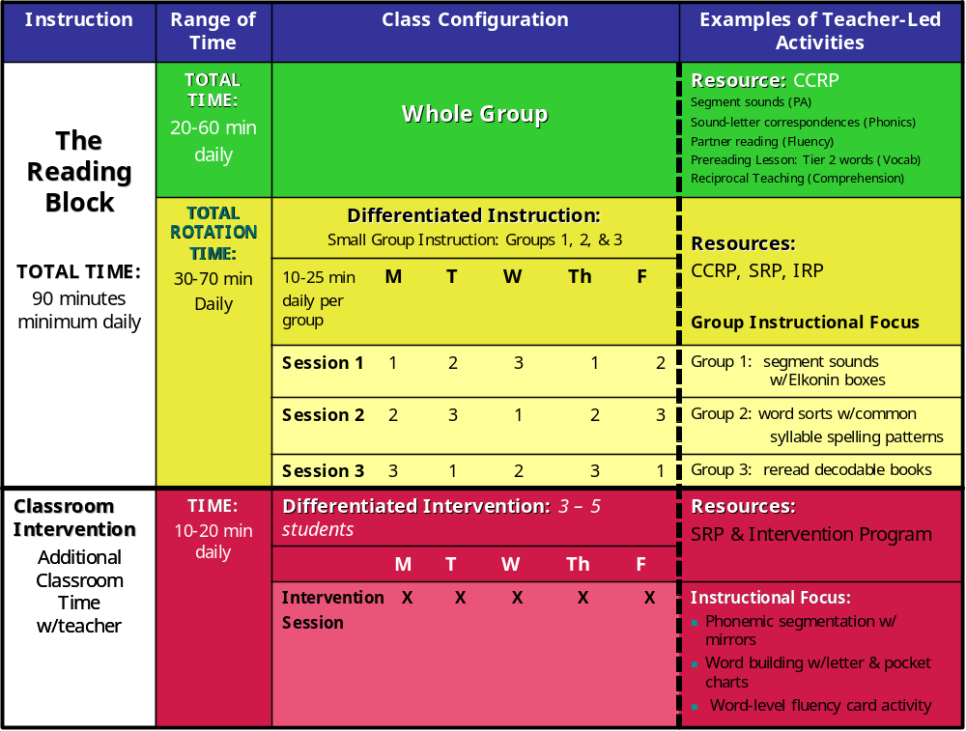
Sample

CCRP = Comprehensive Core Reading Program
SRP = Supplementary Reading Program
IRP =Intensive Intervention Program

Ruth Gumm, 2004. “90-Minute block” Reading First National Conference, MN
Assessing Implementation of Change
STAGES OF CONCERN

Typical Expressions of Concern About the Innovation

Stages of Concern |  |  | Expressions of Concern | Appropriate Assistance
Impact | 6. | Refocusing | I have some ideas about something that would work even better.
Impact | 5. | Collaboration | I am concerned about what I am doing with what other instructors are doing.
Impact | 4. | Consequence | How is my use affecting kids? How can I refine it to have more impact?
Task | 3. | Management | I seem to be spending all my time in getting materials.
Self | 2. | Personal | How will using it affect me?
Self | 1. | Informational | I would like to know more about it.
Self | 0. | Awareness | I am not concerned about it (the innovation)

Adapted from: Shirley M. Hord, William L. Rutherford, Leslie Huling-Austin, and Gene E. Hall. Taking Charge of Change. Alexandria, VA, and Austin, TX: SEDL, 1987.

Concerns-Based Adoption Model (CBAM)
Levels of Use of an Innovation

Instructions: Please read the descriptions of each of the eight levels related to adoption of your core program. Choose the level that best fits where you are in the adoption of the core.

Level 0: Non-use
I have little or no knowledge of this core program, no involvement with it, and I am doing nothing toward becoming involved.

Level 1: Orientation
I am seeking or acquiring information about this core program.

Level 2: Preparation
I am preparing for the first use of this core program.

Level 3: Mechanical Use
I focus most effort on the short-term, day-to-day use of the core with little time for reflection. My effort is primarily directed toward mastering tasks required to use the core in my classroom.

Level 4 A: Routine
I feel comfortable using the core program in my classroom. However, I am putting forth little effort and thought to improve my use of the core program or its consequences.

Level 4 B: Refinement
I vary the use of the core program to increase the expected benefits within the classroom. I am working on using the core program in a differentiated manner to maximize the effects with my students.

Level 5: Integration
I am combining my own efforts with related activities of other teachers and colleagues to achieve impact in the classroom.

Level 6: Renewal
I reevaluate the quality of use of the core program, seek major modifications of, or alternatives to, present innovation to achieve increased impact, examine new developments in the field, and explore new goals for myself and my school or district.
Griffin, D. and Christensen, R. (1999). Concerns-Based Adoption Model (CBAM) Levels of Use of an Innovation (CBAM-LOU).Denton, Texas: Institute for the Integration of Technology into Teaching and Learning.

Directions:

- Look at the examples (below) of teacher behavior at various Levels of Use (LoU) in the implementation of formative assessments in literacy.
- Using the chart on the previous page, identify the LoU in the following examples:

Example 1:

In the fall Fran and Joan decided to use the same formative assessments with their 3rd grade classes. They are now able to compare how well students are learning the benchmarks. Fran’s students were not doing as well as Joan’s in two areas. So this term she is using Joan’s lesson plans to see if her students will do better.

LoU: _____________________________________________

Example 2:

Jose attended a workshop on the importance of using formative assessments. He has not decided to include formative assessments in his teaching, but he is thinking about it. He has spoken with his department chair and one of his colleagues.

LoU: ______________________________________________

Example 3:

Adele is using formative assessments the same way this year that she did last year. She has a bank of them and can pull out the most appropriate ones to use as she goes along. She sees them as important to knowing what her students understand. She finds that her assessments correlate well with how her students do on the state tests.

LoU: _______________________________________________

Example 4:

When asked, Mary states that she does not know anything about formative assessments. She has not talked with anyone about them and has no plans to do so. Yes, it was mentioned at a faculty meeting, but she didn’t pay attention.

LoU:________________________________________________

Example 5:

Chancellor has used formative assessments and found that they really help with student understanding and his knowing how each student is progressing. Now he is looking into a computerized system that will administer the tests, Keep each student’s record, and compile a class profile.

LoU: ______________________________________________

Example 6:

Greg is spending at least 2 hours every weekend developing formative assessments to use in the coming week. Some of his assessments have worked, but several have been confusing to his students. He has had to rework those plus build the new ones for the subsequent week. He also developed some that he never had time to use.

LoU: ______________________________________________

Example 7:

Jeff has compiled the data from the assessments that he used last term. He sees that some of his students consistently perform lower, but he believes they really have learned the material. As he has checked into it, he has seen a pattern; those students who do not read as well are not performing as well on his formative assessments. He now is going to develop and try some assessments that do not rely on reading.

LoU: ______________________________________________

Example 8:

In Betsey’s school the principal has decided that all teachers will do formative assessments. Betsey has bought two books about formative assessments and found several useful sites on the Web. These sites have provided several assessments that she thinks she can use. They have helped her prepare to start using formative assessments next term.

LoU: _______________________________________________
Tier 1 Instruction
Whole Group/Small Group Reading Plan
Grade 1

DAY 1
Whole Group Instruction | Open Routines / Building Content Knowledge  - Oral Vocabulary  - Build Background Knowledge  - Concept Development  Text-Based Comprehension  - Introduce Comprehension Skill/Strategy  - Read Aloud for modeling Comprehension/Vocabulary  Phonemic Awareness  - Oral Blending  - Oral Segmentation  Phonics  - Sound-Spelling Correspondences  - Sound Blending  - Regular Word Reading  - Irregular Word Reading  - High Frequency Words  - Connected Text Reading
Small Group Instruction | See alternate small group plans: Advanced, On-Level, Below Level, Well Below level and ELL  - Differentiated skills work identified by data  - Decodable Text reading to follow up skills work
Written Language / Grammar | Conventions and Grammar  Writing

DAY 2
Whole Group Instruction | Open Routines / Building Content Knowledge  - Oral Vocabulary  - Build Background Knowledge  - Concept Development  Phonemic Awareness  Phonics  - Sound-Spelling Correspondences  - Sound Blending  - Regular Word Reading  - Irregular Word Reading  - High Frequency Words  - Connected Text Reading  Text-Based Comprehension  - Comprehension Skill/Strategy  - Intro to selected text  - Read text for basic comprehension
Small Group Instruction | See alternate small group plans: Advanced, On-Level, Below Level, Well Below level and ELL  - Differentiated skills work identified by data  - Decodable Text reading to follow up skills work  - Grade Level Connected Text reading to deepen comprehension and vocabulary
Written Language / Grammar | Conventions and Grammar  Writing

DAY 3
Whole Group Instruction | Open Routines / Building Content Knowledge  - Oral Vocabulary  - Build Background Knowledge  - Concept Development  Phonemic Awareness  Phonics  High-Frequency Word Practice  Text-Based Comprehension  - Comprehension Skill/Strategy  - Re-visit selected text  Close read text to ensure critical thinking  Discuss for deeper comprehension  Look back and write  Cite text evidence  Respond to text in writing
See alternate small group plans: Advanced, On-Level, Below Level, Well Below level and ELL
- Differentiated skills work identified by data
- Decodable Text reading to follow up skills work
- Grade Level Connected Text reading to deepen comprehension and vocabulary

Written Language / Grammar | Conventions and Grammar  Writing

DAY 4
Whole Group Instruction | Open Routines / Building Content Knowledge  - Oral Vocabulary  - Build Background Knowledge  Concept Development  Phonemic Awareness  Phonics  - High-Frequency Word Practice  Review earlier skills and integrate with current phonetic elements  Text-Based Comprehension –  Either continue with plan from previous day with a high focus on written response to text  Comprehension Skill/Strategy plus review and integration with earlier taught skills.  Re-visit selected text  Close read text to ensure critical thinking  Discuss for deeper comprehension  Look back and write  Cite text evidence  Respond to text in writing  Or use leveled readers to ensure generalization of comprehension skill and writing to  sources using a new text cold? Unmediated? Fresh?
Small Group Instruction | See alternate small group plans: Advanced, On-Level, Below Level, Well Below level and ELL  - Differentiated skills work identified by data  - Decodable Text reading to follow up skills work  Leveled Connected Text reading to deepen comprehension and vocabulary
Written Language / Grammar | Conventions and Grammar  Writing

DAY 5
Whole Group Instruction | Wrap Up / Content Knowledge  - Review Oral Vocabulary and Concept Development  - Connect and Extend  Carefully selected weekly assessments  Phonemic Awareness  Phonics  High-Frequency Word Practice  Review earlier skills and integrate with current phonetic elements  Text-Based Comprehension –  Constructed Response Practice assessment
Small Group Instruction | See alternate small group plans: Advanced, On-Level, Below Level, Well Below level and ELL  - Differentiated Skills work identified by data  - Decodable Text reading to follow up skills work  Leveled Connected Text reading to deepen comprehension and vocabulary
Written Language / Grammar | Conventions and Grammar  Writing

Tier 1 Instruction
Whole Group/Small Group Reading Plan Template

DAY 1
Whole Group Instruction
Small Group Instruction
Written Language / Grammar

DAY 2
Whole Group Instruction
Small Group Instruction
Written Language / Grammar

DAY 3
Whole Group Instruction
Small Group Instruction
Written Language / Grammar

DAY 4
Whole Group Instruction
Small Group Instruction
Written Language / Grammar

DAY 5
Whole Group Instruction
Small Group Instruction
Written Language / Grammar

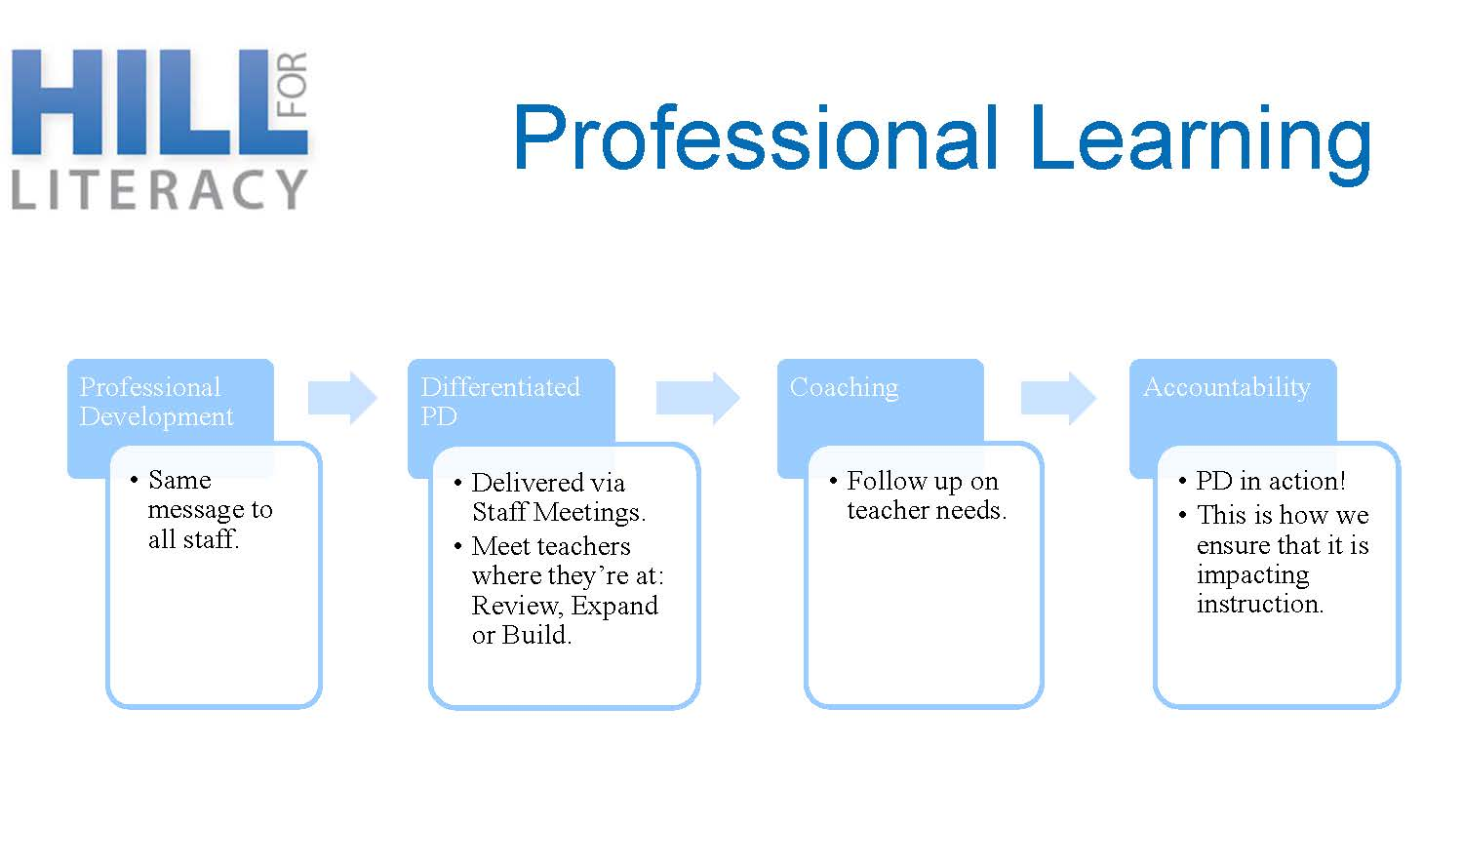

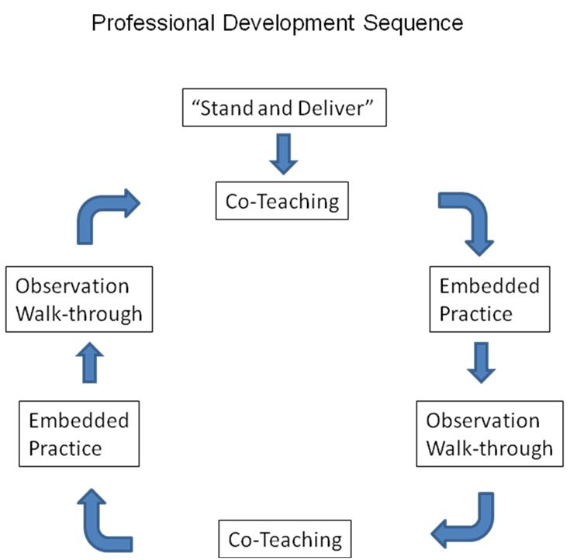

Monitoring Implementation
- Purpose of Observation? (Evaluative or Instructional?)
- Structure of Observation?
  - Whole lesson (90 minute)
    - See entire structure, transitions, classroom management
    - In-depth and deep observation
  - Part of lesson (10 minute)
    - Look for a specific skill or strategy that you have been working on in PD
    - Superficial and broad

Classroom Observation

Rationale:
Principals greatly benefit as reading leaders when they understand research-based teaching strategies, recognize strengths in their teachers' practice, and note areas that need improvement. Observation and conferencing are primary responsibilities of instructional leaders. (Glickman, 1985; Pajak, 1989; Scholastic, 2005)

Purpose:
The purpose of a classroom visit is to help teachers improve their instruction and identify the best teaching practices in your school. Observation visits reflect your interest in instruction and in your staff's professional growth. (Blase & Blase, 1998; Scholastic, 2005)

Specifically:
- to improve instructional outcomes
- to strengthen instructional leadership
  - be visible -be
  - supportive
  - be engaged
  - be knowledgeable
  - to reinforce recent training teachers have had
- to support the coaching process
- to assure that time planned is actually delivered
- to assure that literacy elements are being implemented

Benefits:
- Critical in monitoring program implementation and student progress
- Builds rapport, teamwork and professional credibility with staff
- Improves accountability
- Builds principal knowledge of instructional practices
- Informs implementation decisions
Challenges:
- Time
- Knowledge of effective reading instruction
- Understanding what to look for
- Collection and analysis of appropriate observational data

Indicator Categories:
- Classroom Environment
- Materials
- Teacher Instruction
- Whole Class Instruction
- Small Group, Differentiated Instruction
- Student Reading Centers
- Phonemic Awareness
- Phonics
- Fluency
- Vocabulary
- Comprehension

How to be Prepared:
- Understand the reading process and be able to articulate it to teachers and parents.
- Be knowledgeable about the components of effective reading instruction and the framework necessary for supporting it.
- Review individual classroom timetables to ensure that they provide effective reading blocks.
- Monitor teachers’ reading programs to ensure that the components are effectively implemented and observable in classrooms.
- Ensure that reading resources are available and accessible to all.
- Visit classrooms to observe reading instruction.

(Report of the Expert Panel on Early Reading in Ontario, 2003)

Gaining Staff Support:
- Create an atmosphere of trust and support.
- Be constructive.
- Use data to improve school-wide implementation of effective reading programs.

Reference Article:

Hall, P.A. (June 2005). The Principal’s Presence and Supervision to Improve Teaching. SEDL Letter. (pp 12 - 16). http://www. sedl.org/pubs/sedl-letter/

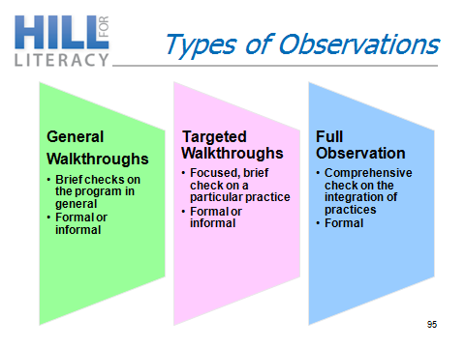

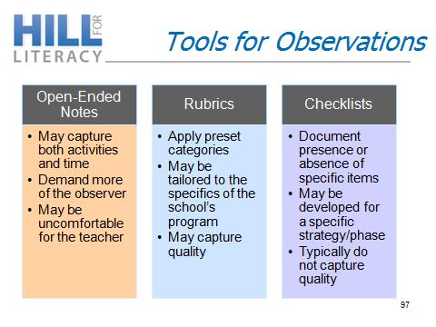

Review Walk-through tools: Handouts
- CK3LI Fidelity of Implementation Tools
- Teacher Checklist_Whole Group Template
- Teacher Checklist_Small Group Template
- ECRI Implementation Checklist
CK3LI
Fidelity of Implementation Overview

We collect information about implementation in order to:
- Document components of instruction
- Identify which components of instruction require additional support
- Plan coaching and professional development efforts that are aligned with, and responsive to, teacher needs
- Determine implementation of Tier 1/2 instructional practices across the CK3LI project to inform the development and refinement of the CT K-3 Reading Model

All information we collect about implementation:
- Are completely confidential. Individual de-identified implementation checklists will be stored securely at UConn and will not be shared with school, district, or state personnel.
- Will not be used to evaluate teachers. Data will only be analyzed at the project level, not at the level of individual teachers.

CK3LI SY 2016-17: Implementation Checklist and Coaching Procedures

- Provide classroom teacher/interventionists with a copy of the Implementation Checklist as well as well as the Teacher Checklist prior to your scheduled observation time. Review the Overview if necessary, to ensure they understand the purpose of the tools. Discuss any questions the teacher has and explain to them how the follow-up feedback session will work.

- Observe the teacher using the Implementation Checklist while following along with the Teacher's Manual and ECRI Checklist tool. The implementation checklist will be individualized to the whole group lesson plan that you have designed at each grade level.

- After the observation, use the Implementation Observation Feedback Tool (to identify specific target areas and specific items to focus on during the feedback session.

- Conduct a feedback session with the teacher or a small group of grade level teachers using the Coaching Log.
- Use the debriefing questions to begin the session.
- Use your notes from the feedback tool and checklist to provide targeted and constructive feedback
- Use the Implementation Goals form to identify and record one or more areas to focus on. (Provide one copy to the teacher and save one copy) This should be done collaboratively with the teacher(s) during the feedback session.

- Keep copies of all documents and share with the teachers if requested. Although we understand that each Literacy Coach will probably use these forms somewhat differently, we would like you to save then so we can look for trends, etc.

Observation Plan
- Each classroom teacher will be observed (2) times during the school year.

- Each teacher/interventionist (strategic groups) will be observed (2) times during the school year.

Implementation Checklist: Whole Group (SAMPLE)

This form is to be used by the reading coach during the classroom implementation observation. A copy of this form as well as the teacher check-in tool should be given to the teacher prior to the implementation observation. Keep this completed form, and leave a copy with the teacher if requested.
 | Not applicable | Did not do the activity | Completed SOME of the activity as specified | Completed MOST of the activity as specified | Completed ALL of the activity as specified | 
Content Knowledge
- Question of the Week | ☐ | ☐ | ☐ | ☐ | ☐ | Start Time:  __: ____  End Time:  __: ____
- Concept Talk | ☐ | ☐ | ☐ | ☐ | ☐ | Start Time:  __: ____  End Time:  __: ____
- Amazing Words Sing with me chart | ☐ | ☐ | ☐ | ☐ | ☐ | Start Time:  __: ____  End Time:  __: ____
- Robust Vocabulary Routine | ☐ | ☐ | ☐ | ☐ | ☐ | Start Time:  __: ____  End Time:  __: ____
ECRI
- Say it, Spell it, Say It | ☐ | ☐ | ☐ | ☐ | ☐ | Start Time:  __:____  End Time:  __: ____
- Irregular Word Reading | ☐ | ☐ | ☐ | ☐ | ☐ | Start Time:  __:____  End Time:  __: ____
- Phoneme Blending | ☐ | ☐ | ☐ | ☐ | ☐ | Start Time:  __:____  End Time:  __: ____
- Letter name review | ☐ | ☐ | ☐ | ☐ | ☐ | Start Time:  __:____  End Time:  __: ____
- Sound Spelling Cards Intro & Practice | ☐ | ☐ | ☐ | ☐ | ☐ | Start Time:  __:____  End Time:  __: ____
- Sound Spelling Review Beginning | ☐ | ☐ | ☐ | ☐ | ☐ | Start Time:  __:____  End Time:  __: ____
- Sound Spelling Review Advanced | ☐ | ☐ | ☐ | ☐ | ☐ | Start Time:  __:____  End Time:  __: ____
- Sound Spelling Review Cont. Blending | ☐ | ☐ | ☐ | ☐ | ☐ | Start Time:  __:____  End Time:  __: ____
- Sound by Sound Blending | ☐ | ☐ | ☐ | ☐ | ☐ | Start Time:  __:____  End Time:  __: ____
Text Based Comprehension
- Information Elements | ☐ | ☐ | ☐ | ☐ | ☐ | Start Time:  __: ____  End Time:  __: ____
- Envision It Video (Day 1) | ☐ | ☐ | ☐ | ☐ | ☐ | Start Time:  __: ____  End Time:  __: ____
- Read Aloud (Day 1) | ☐ | ☐ | ☐ | ☐ | ☐ | Start Time:  __: ____  End Time:  __: ____
- Introduce the Main Selection | ☐ | ☐ | ☐ | ☐ | ☐ | Start Time:  __: ____  End Time:  __: ____
- Retell (Day 2) | ☐ | ☐ | ☐ | ☐ | ☐ | Start Time:  __: ____  End Time:  __: ____
- Second Main Selection Read (3) | ☐ | ☐ | ☐ | ☐ | ☐ | Start Time:  __: ____  End Time:  __: ____

Date: _______________________  Check-in #: 1 2 | Teacher ID:___________  School: _______________  Grade: _______________ | Lesson #: _______  Lesson Start/End Time: ______ - _______  Length of Lesson: ___________________ | Coach: _____________  Reliability Check-in:  Yes No

Notes:

Implementation Checklist: Small/Intervention Group – SAMPLE K
This form is to be used by the reading coach during the small group/strategic intervention observation. A copy of this form as well as the teacher check-in tool should be given to the teacher prior to the implementation observation. Keep this completed form, and leave a copy with the teacher if requested.

Date: _______________________  Level:_______________________  Check-in #: 1 2 | Teacher ID:___________  School: _______________  Grade: _______________ | Lesson #: _______  Lesson Start/End Time: ______ - _______  Length of Lesson: ___________________ | Coach: _____________  Reliability Check-in:  Yes No

 |  | Not applicable | Did not do the activity | Completed SOME of the activity as specified | Completed MOST of the activity as specified | Completed ALL of the activity as specified
ECRI
- Say it, Spell it, Say It |  | ☐ | ☐ | ☐ | ☐ | ☐ | Start Time:  __:____  End Time:  __: ____
- Irregular Word Reading |  | ☐ | ☐ | ☐ | ☐ | ☐ | Start Time:  __:____  End Time:  __: ____
- Phoneme Blending |  | ☐ | ☐ | ☐ | ☐ | ☐ | Start Time:  __:____  End Time:  __: ____
- Sound Spelling Cards Intro & Practice |  | ☐ | ☐ | ☐ | ☐ | ☐ | Start Time:  __:____  End Time:  __: ____
- Letter Name |  | ☐ | ☐ | ☐ | ☐ | ☐ | Start Time:  __:____  End Time:  __: ____
- Sound Spelling Review Beginning |  | ☐ | ☐ | ☐ | ☐ | ☐ | Start Time:  __:____  End Time:  __: ____
- Continuous Blending |  | ☐ | ☐ | ☐ | ☐ | ☐ | Start Time:  __:____  End Time:  __: ____
- Sound by Sound Blending |  | ☐ | ☐ | ☐ | ☐ | ☐ | Start Time:  __:____  End Time:  __: ____
- Regular Word Reading |  | ☐ | ☐ | ☐ | ☐ | ☐ | Start Time:  __:____  End Time:  __: ____
- Decodable Text Routine |  | ☐ | ☐ | ☐ | ☐ | ☐ | Start Time:  __:____  End Time:  __: ____
- Fluency Routine |  | ☐ | ☐ | ☐ | ☐ | ☐ | Start Time:  __:____  End Time:  __: ____
- Phoneme Segmentation |  | ☐ | ☐ | ☐ | ☐ | ☐ | Start Time:  __:____  End Time:  __: ____
- Dictation |  | ☐ | ☐ | ☐ | ☐ | ☐ | Start Time:  __:____  End Time:  __: ____
- Needs More Practice Sheet |  | ☐ | ☐ | ☐ | ☐ | ☐ | Start Time:  __:____  End Time:  __: ____
- Fluency/Accuracy Log |  | ☐ | ☐ | ☐ | ☐ | ☐ | Start Time:  __:____  End Time:  __: ____
Text Based Comprehension
- Narrative/Informational Text Poster |  | ☐ | ☐ | ☐ | ☐ | ☐ | Start Time:  __: ____  End Time:  __: ____
- Student Retell: (Narrative/Informational Text Bookmarks) |  | ☐ | ☐ | ☐ | ☐ | ☐ | Start Time:  __: ____  End Time:  __: ____
- Written Retell Form (ECRI)/Written Summary |  | ☐ | ☐ | ☐ | ☐ | ☐ | Start Time:  __: ____  End Time:  __: ____
- Decodable Text/Leveled Reader: |  | ☐ | ☐ | ☐ | ☐ | ☐ | Start Time:  __: ____  End Time:  __: ____

Notes:

Whole Group Reading Instruction: Teacher Checklist (SAMPLE)

This form is to be used by the classroom teacher after the implementation observation and prior to the post observation debrief/implementation meeting.
 | Not applicable | Did not do the activity | Completed SOME of the activity as specified | Completed MOST of the activity as specified | Completed ALL of the activity as specified
Content Knowledge
- Question of the Week | ☐ | ☐ | ☐ | ☐ | ☐
- Concept Talk | ☐ | ☐ | ☐ | ☐ | ☐
- Amazing Words Sing with me chart | ☐ | ☐ | ☐ | ☐ | ☐
- Robust Vocabulary Routine | ☐ | ☐ | ☐ | ☐ | ☐
ECRI
- Say it, Spell it, Say It | ☐ | ☐ | ☐ | ☐ | ☐
- Irregular Word Reading | ☐ | ☐ | ☐ | ☐ | ☐
- Phoneme Blending | ☐ | ☐ | ☐ | ☐ | ☐
- Letter name review | ☐ | ☐ | ☐ | ☐ | ☐
- Sound Spelling Cards Intro & Practice | ☐ | ☐ | ☐ | ☐ | ☐
- Sound Spelling Review Beginning | ☐ | ☐ | ☐ | ☐ | ☐
- Sound Spelling Review Advanced | ☐ | ☐ | ☐ | ☐ | ☐
- Sound Spelling Review Cont. Blending | ☐ | ☐ | ☐ | ☐ | ☐
- Sound by Sound Blending | ☐ | ☐ | ☐ | ☐ | ☐
Text Based Comprehension
- Information Elements | ☐ | ☐ | ☐ | ☐ | ☐
- Envision It Video (Day 1) | ☐ | ☐ | ☐ | ☐ | ☐
- Read Aloud (Day 1) | ☐ | ☐ | ☐ | ☐ | ☐
- Introduce the Main Selection | ☐ | ☐ | ☐ | ☐ | ☐
- Retell (Day 2) | ☐ | ☐ | ☐ | ☐ | ☐
- Second Main Selection Read (3) | ☐ | ☐ | ☐ | ☐ | ☐

Questions to reflect on:

What do you think worked well during the lesson?

What didn’t work so well?

What would you do differently next time?

Small Group Instruction: Teacher Checklist
Grade 1

Date: _________________________ Unit: _______________ Day:__________
 | Not applicable | Did not do the activity | Completed SOME of the activity as specified | Completed MOST of the activity as specified | Completed ALL of the activity as specified
ECRI
- Say it, Spell it, Say It | ☐ | ☐ | ☐ | ☐ | ☐
- Irregular Word Reading | ☐ | ☐ | ☐ | ☐ | ☐
- Phoneme Blending | ☐ | ☐ | ☐ | ☐ | ☐
- Letter name review | ☐ | ☐ | ☐ | ☐ | ☐
- Sound Spelling Cards Intro & Practice | ☐ | ☐ | ☐ | ☐ | ☐
- Sound Spelling Review Beginning | ☐ | ☐ | ☐ | ☐ | ☐
- Sound Spelling Review Advanced | ☐ | ☐ | ☐ | ☐ | ☐
- Sound Spelling Review Cont. Blending | ☐ | ☐ | ☐ | ☐ | ☐
- Sound by Sound Blending | ☐ | ☐ | ☐ | ☐ | ☐
- Spelling-Focused Blending | ☐ | ☐ | ☐ | ☐ | ☐
- Affix Review | ☐ | ☐ | ☐ | ☐ | ☐
- Contraction Review | ☐ | ☐ | ☐ | ☐ | ☐
- Spelling-Focused Multi-syllabic | ☐ | ☐ | ☐ | ☐ | ☐
- Decodable Text Routine | ☐ | ☐ | ☐ | ☐ | ☐
- Fluency Routine | ☐ | ☐ | ☐ | ☐ | ☐
- Phoneme Segmentation | ☐ | ☐ | ☐ | ☐ | ☐
- Dictation | ☐ | ☐ | ☐ | ☐ | ☐
- Needs More Practice Sheet | ☐ | ☐ | ☐ | ☐ | ☐
- Fluency/Accuracy Log | ☐ | ☐ | ☐ | ☐ | ☐
Text Based Comprehension
- Narrative/Informational Text Poster | ☐ | ☐ | ☐ | ☐ | ☐
- Student Retell: Narrative/Informational Text Bookmarks | ☐ | ☐ | ☐ | ☐ | ☐
- Written Retell Form (ECRI)/Written Summary | ☐ | ☐ | ☐ | ☐ | ☐
- Decodable Text/Leveled Reader: | ☐ | ☐ | ☐ | ☐ | ☐
- Main Selection, Close Read | ☐ | ☐ | ☐ | ☐ | ☐
- Sleuth, Close Read | ☐ | ☐ | ☐ | ☐ | ☐
- Comprehension Questions, Oral/Written | ☐ | ☐ | ☐ | ☐ | ☐
- Look Back and Write Strategy | ☐ | ☐ | ☐ | ☐ | ☐

Questions to reflect on:
What do you think worked well during the lesson?
What didn’t work so well?
What would you do differently next time?

CK3LI SY 2016-17: Implementation Feedback Tool

Teacher ID: |  | School:
Check-In #: | Date: |  | Duration of visit:
This form is to be used as a reference by the coach to prepare for the feedback session with the teacher/interventionist. The areas for feedback serve to guide the debriefing and target specific areas of the instruction. Choose the three highest priority areas to target feedback and mark the selected three items on this page. Keep this form, and leave a copy of the observation/coaching log, if requested.

Target for feedback: | Specific items to consider:
❑ Content Knowledge | ❑ Include a _______________ missed step(s) in an activity.   Adhere more closely to the teacher manual in the following areas: ____________________________   Adhere more closely to the use of materials   Adjust Pacing based on students who are having difficulty   Adjust pacing in order to cover all components of lesson   Other: _________________________________________________________
❑ ECRI/Fundations/ERI, etc. | ❑ Include a _______________ missed step(s) in an activity.   Adhere more closely to the teacher manual in the following areas: ____________________________   Adhere more closely to the use of materials   Adjust Pacing based on students who are having difficulty   Adjust pacing in order to cover all components of lesson   Other: _________________________________________________________   Review the __________________ Routine Checklist
❑ Text-Based Comprehension | ❑ Include a _______________ missed step(s) in an activity.   Adhere more closely to the teacher manual in the following areas:____________________________   Adhere more closely to the use of materials   Adjust Pacing based on students who are having difficulty   Adjust pacing in order to cover all components of lesson   Other: _________________________________________________________
❑ Student Engagement | Pre-correct (restate) positively & acknowledge before problem reoccurs.   Review classroom behavior expectations   Acknowledge displays of behavior expectations   Respond quickly and briefly to minor problems
Modifications: Were modifications to the whole group/small group template discussed? Yes No
If yes, please describe: ____________________________________________________________________________________________________________________________________________________________________
CK3LI Implementation/Fidelity Coaching Log
Teacher(s) ID #: | School:
Check-in #:1 2 3 | Date:
Debriefing: Ask the teacher(s) the following three questions and use their responses to provide feedback.

1. What do you think worked well during the lesson?

2. What didn’t work so well?

3. What would you do differently next time?

Notes:

This form is to be completed by the coach during the feedback session with the teacher(s).

Implementation Goals

This form is to be used during the feedback session with the teacher(s) and the coach. The coach and teacher(s) will reflect together and set implementation goals collaboratively.

Teacher: _________________________________

Coach: ___________________________________

Date: ___________________

Areas on which to focus:
❶
❷
❸

Whole Group Reading Instruction: Teacher Checklist
Date: _________________________ Unit: _______________ Day:__________
 | Not applicable | Did not do the activity | Completed SOME of the activity as specified | Completed MOST of the activity as specified | Completed ALL of the activity as specified
Content Knowledge
 | ☐ | ☐ | ☐ | ☐ | ☐
 | ☐ | ☐ | ☐ | ☐ | ☐
 | ☐ | ☐ | ☐ | ☐ | ☐
 | ☐ | ☐ | ☐ | ☐ | ☐
ECRI
 | ☐ | ☐ | ☐ | ☐ | ☐
 | ☐ | ☐ | ☐ | ☐ | ☐
 | ☐ | ☐ | ☐ | ☐ | ☐
 | ☐ | ☐ | ☐ | ☐ | ☐
 | ☐ | ☐ | ☐ | ☐ | ☐
 | ☐ | ☐ | ☐ | ☐ | ☐
 | ☐ | ☐ | ☐ | ☐ | ☐
 | ☐ | ☐ | ☐ | ☐ | ☐
 | ☐ | ☐ | ☐ | ☐ | ☐
Text Based Comprehension
 | ☐ | ☐ | ☐ | ☐ | ☐
 | ☐ | ☐ | ☐ | ☐ | ☐
 | ☐ | ☐ | ☐ | ☐ | ☐
 | ☐ | ☐ | ☐ | ☐ | ☐
 | ☐ | ☐ | ☐ | ☐ | ☐
 | ☐ | ☐ | ☐ | ☐ | ☐

Questions to reflect on:

What do you think worked well during the lesson?

What didn’t work so well?

What would you do differently next time?

Small Group Reading Instruction: Teacher Checklist

Date: _________________________ Unit: _______________ Day:__________
 | Not applicable | Did not do the activity | Completed SOME of the activity as specified | Completed MOST of the activity as specified | Completed ALL of the activity as specified
 | ☐ | ☐ | ☐ | ☐ | ☐
 | ☐ | ☐ | ☐ | ☐ | ☐
 | ☐ | ☐ | ☐ | ☐ | ☐
 | ☐ | ☐ | ☐ | ☐ | ☐
 | ☐ | ☐ | ☐ | ☐ | ☐
 | ☐ | ☐ | ☐ | ☐ | ☐
 | ☐ | ☐ | ☐ | ☐ | ☐
 | ☐ | ☐ | ☐ | ☐ | ☐
 | ☐ | ☐ | ☐ | ☐ | ☐
 | ☐ | ☐ | ☐ | ☐ | ☐
 | ☐ | ☐ | ☐ | ☐ | ☐
 | ☐ | ☐ | ☐ | ☐ | ☐
 | ☐ | ☐ | ☐ | ☐ | ☐
 | ☐ | ☐ | ☐ | ☐ | ☐
 | ☐ | ☐ | ☐ | ☐ | ☐
 | ☐ | ☐ | ☐ | ☐ | ☐
 | ☐ | ☐ | ☐ | ☐ | ☐
 | ☐ | ☐ | ☐ | ☐ | ☐
 | ☐ | ☐ | ☐ | ☐ | ☐

Questions to reflect on:

What do you think worked well during the lesson?

What didn’t work so well?

What would you do differently next time?
Enhanced Reading Instruction Observation and Feedback Form
Review
Teacher Name:
Date: Time Observed:

Materials and Organization | Delivery and Engagement
☐ The teacher had the appropriate materials ready.  ☐ The following were posted in the classroom where all students could see them and the teacher could easily refer to them during the reading lesson:  ☐ Core program sound-spelling cards  ☐ Irregular word wall  ☐ Vocabulary words with student-friendly definitions  ☐ Narrative text elements poster  ☐ Information text elements poster  ☐ Reading routines and rules had been taught, practiced, implemented and were being positively reinforced.  ☐ Students were seated where they could easily see the instruction and there was minimal distraction during the lesson. | ☐ Routine: The teacher followed the actual language throughout the routine.  ☐ Model: The teacher showed one to two examples when  students are first learning the routine and skips the model  once students are successful with the routine.  ☐ Check for Understanding: The teacher provided two to three  individual turns at the end of presenting each list of letters,  sounds, or words.  ☐ The teacher is looked at the students to monitor their  responses.  ☐ Only the students responded during student practice and  the teacher did not “mouth” answers or give clues.  ☐ The teacher moved quickly from item to item and did not  add in extra talking to maintain appropriate and lively  pacing for maximum student engagement.  ☐ All students responded during practice opportunities.

Say-it, spell-it, say-it | Signal for each word: | Correcting Student Errors:
Say-it, spell-it, say-it | ☐ 1. Touch to the left of the word. My turn. The word  is… Slide finger under the word [word].  ☐ 2. Touch to the left of the word. Your turn. Word? Slide  finger under the word for the students to respond.  ☐ 3. Touch to the left of the word. Spell [word]. Tap  under each letter as students spell the word.  ☐ 4. Touch to the left of the word. Word? Slide finger  under the word for the students to respond.  ☐ 5. Repeat steps 1 through 4 for the remaining words. | ☐ Word Error: My turn. This word is [word]. Your turn.  Everyone, word? Let’s start again. Re-present the  missed word using steps 1 through 4 above. Continue  presenting the remaining words.  ☐ Spelling Error: My turn. This letter is [spelling]. Your  turn. Everyone, letter? Let’s start again. Re-present the  missed word using steps 1 through 4 above. Continue  presenting the remaining words.
Say-it, spell-it, say-it |  | ☐ Timing: < 30 seconds

Irregular Word Reading | Signal for each word: | Correcting Student Errors:
Irregular Word Reading | ☐ Touch (not tap) to the left of the word. Word?  ☐ Wait 2 seconds for students to think.  ☐ Slide finger under the word. | ☐ Follow the say-it, spell-it, say-it steps 1 through 4 for  each missed word.  ☐ Back up two words and use the signal for each word* to  continue presenting the words on the chart.
Irregular Word Reading |  | ☐ Timing: < 2-1/2 minutes

Phoneme  Blending | Signal for each word: | Correcting Student Errors:
Phoneme  Blending | ☐ Tap one cube from right to left as you say each sound of  the word (this will be the correct direction from the student perspective).  ☐ Slide finger above the cubes from right to left. | ☐ My turn. Use the signal for each word* and re-present  the missed word.  ☐ Your turn. Use the signal for each word* and re-present  the missed word.  ☐ Back up two words and use the signal for each word* to  continue presenting the words from the list.
Phoneme  Blending |  | ☐ Timing: < 1 minute

Letter Name | Signal for each word: | Correcting Errors:
Letter Name | ☐ Touch to the left of the letter. Name?  ☐ Wait 2 seconds for students to think.  ☐ Tap finger under the letter. | ☐ My turn. Re-present the missed letter name.  ☐ Your turn. Re-present the missed letter name.  ☐ Back up two letters and continue presenting the letter  names on the chart.
Letter Name |  | ☐ Timing: < 1 minute

Sound-Spelling Card Introduction and Practice | Signal for each word: | Correcting Student Errors:
Sound-Spelling Card Introduction and Practice | Introduction:  ☐ 1. Touch to the side of the picture. The card is [card name]. Card? (pause) Tap to the side of the picture.  ☐ 2. Touch to the side of the picture. The sound is [sound].  Sound? (pause) Tap to the side of the picture.  ☐ 3. Touch to the side of the spelling. The spelling is [spelling]. Spelling? (pause) Tap to the side of the spelling.  ☐ 4. Repeat step 3 for each additional spelling on the card.  ☐ 5. Repeat steps 1 through 4 for each of the new cards.  Practice:  ☐ 1. Touch to the side of the picture. Card? (pause) Tap to  the side of the picture.  ☐ 2. Touch to the side of the picture. Sound? (pause) Tap  to the side of the picture.  ☐ 3. Touch to the side of the spelling. Spelling? (pause)  Tap to the side of the spelling.  ☐ 4. Repeat step 3 for each additional spelling on the card. | ☐ Let’s practice this one together.  ☐ Follow the signal to introduce a new sound-spelling card* steps 1 through 4.  ☐ Practice two other sound-spelling cards.  ☐ Re-present the missed card following the signal to  practice the sound-spelling card** steps 1 though 4.  ☐ Continue presenting the sound-spelling cards.
Sound-Spelling Card Introduction and Practice |  | ☐ Timing: < 1 minute

Sound-Spelling Review: Beginning | Signal for each word: | Correcting Errors:
Sound-Spelling Review: Beginning | ☐ Touch to the left of the sound-spelling. Sound?  ☐ Wait 2 seconds for students to think.  ☐ For stop sounds, tap finger under the sound-spelling.  -- or --  ☐ For continuous sounds, touch under the sound-spelling  for 2 seconds. | ☐ My turn. Follow the signal for each sound-spelling*  and re-present the missed sound-spelling.  ☐ Your turn. Follow the signal for each sound-spelling*  and re-present the missed sound-spelling.  ☐ Back up two sound-spellings and continue presenting  the sounds on the chart.
Sound-Spelling Review: Beginning |  | ☐ Timing: < 2 minutes

Sound-Spelling Review: Advanced | Signal for each word: | Correcting Errors:
Sound-Spelling Review: Advanced | ☐ Touch to the left of the sound-spelling. Sound?  ☐ Wait 2 seconds for students to think.  ☐ Tap finger(s) under the sound-spelling (use one finger  for each of the letters in the spelling). | ☐ My turn. Follow the signal for each sound-spelling*  and re-present the missed sound-spelling.  ☐ Your turn. Follow the signal for each sound-spelling*  and re-present the missed sound-spelling.  ☐ Back up two sound-spellings and continue presenting  the sounds on the chart.
Sound-Spelling Review: Advanced |  | ☐ Timing: < 2 minutes

Continuous Blending | Signal for each word: | Correcting Errors:
Continuous Blending | ☐ Words beginning with continuous sounds: Touch to the  left of the word. Blend.  ☐ Words beginning with stop sounds: Touch under the  first letter. Blend.  ☐ Loop finger from letter to letter. Pause under each letter  for 1 second for continuous sounds and an instant for  stop sounds.  ☐ Touch again to the left of the word. Word?  ☐ Slide finger under the word. | ☐ Sound Error: My turn. This sound is [sound]. Your  turn. Sound? Tap under spelling. Let’s start over. Use  the signal for each word and re-present the word.  Continue presenting the words on the chart.  ☐ Blending Error: My turn. Watch me blend this word.  Demonstrate blending. Your turn. Blend. Loop finger  from letter to letter. Let’s start over. Use the signal for  each word* and re-present the word. Continue  presenting the words on the chart.  ☐ Word Error: My turn. This word is [word]. Your turn.  Word? Slide finger under the word. Let’s start over. Use the signal for each word* and re-present the word. Continue presenting the words on the chart.
Continuous Blending |  | ☐ Timing: < 2 minutes

Sound-by-Sound Blending | Signal for each word: | Correcting Errors:
Sound-by-Sound Blending | ☐ Sound-spellings: Write spelling. Sound? Tap under  spelling.  ☐ Blend (each time a sound is added): Touch to the left of  the first spelling. Blend? Loop finger under spellings.  ☐ Word Reading: Touch to the left of the word. Word?  Slide finger under the word. | ☐ Sound Error: My turn. This sound is [sound]. Your  turn. Sound? Tap under spelling. Let’s start over. Use the signal for each word* and re-present the word. Continue presenting the words on the chart.  ☐ Blending Error: My turn. Watch me blend this word.  Demonstrate blending. Your turn. Blend. Loop finger  from letter to letter. Let’s start over. Use the signal for  each word* and re-present the word. Continue presenting the words on the chart.  ☐ Word Error: My turn. This word is [word]. Your turn.  Word? Slide finger under the word. Let’s start over.  Use the signal for each word* and re-present the word.  Continue presenting the words on the chart.
Sound-by-Sound Blending |  | ☐ Timing: < 2 minutes

Regular Word  Reading | Signal for each word: | Correcting Errors:
Regular Word  Reading | ☐ Touch (not tap) to the left of the word. Word?  ☐ Wait 2 seconds for students to think.  ☐ Slide finger under the word. | ☐ My turn. Re-present the missed word.  ☐ Your turn. Re-present the missed word.  ☐ Now let’s practice blending that word. Follow the blending routine used in the previous blending activity to have students practice blending the missed word.  ☐ Back up two words and continue presenting the words on the chart.
Regular Word  Reading |  | ☐ Timing: < 2 minutes

Spelling-Focused Blending | Signal for each word: | Correcting Errors:
Spelling-Focused Blending | ☐ Touch finger(s) under the focus spelling (e.g., vowel  spellings). Sound? Wait 1 second for students to think.  Tap finger(s) under spelling.  ☐ Touch to the left of the word. Word? Wait 2 seconds for  students to think. Slide finger under the word. | ☐ Sound Error: My turn. This sound is [sound]. Your  turn. Sound? Tap under spelling. Let’s start over. Use  the signal for each word* and re-present the word.  Continue presenting the words on the chart.  ☐ Word Error: My turn. This word is [word]. Your turn.  Word? Slide finger under the word. Let’s start over.  Use the signal for each word* and re-present the word.  Back up two words and continue presenting the words  on the chart.
Spelling-Focused Blending |  | ☐ Timing: < 2 minutes

Affix Review | Signal for each word: | Correcting Errors:
Affix Review | ☐ Prefix: Touch to the left of the prefix. Prefix?  ☐ Suffix: Touch to the left of the suffix. Suffix?  ☐ Wait 1 second for students to think.  ☐ Slide finger under the affix.  ☐ Touch again to the left of the affix. Meaning?  ☐ Wait 2 seconds for the students to think.  ☐ Slide finger under the affix. | ☐ My turn. Follow the signal for each affix and re-present  the missed affix.  ☐ Your turn. Follow the signal for each affix* and re- present the missed affix.  ☐ Back up two affixes and continue presenting the sounds on the chart.
Affix Review |  | ☐ Timing: < 1 minute

Spelling-Focused Multisyllabic Blending | Signal for each word: | Correcting Errors:
Spelling-Focused Multisyllabic Blending | ☐ Cover all of the syllables except for the first one.  ☐ Touch finger(s) under the focus spelling (e.g., vowel  spellings) of the syllable. Sound? Wait 1 second for  students to think. Tap finger(s) under spelling.  ☐ Touch to the left of the word. Blend. (pause) Loop finger  under each of the syllable(s) that have been presented.  ☐ Uncover the next syllable continuing to move the card to  the right until every syllable is revealed.  ☐ Repeat steps 2 and 3 for each syllable in the word.  ☐ Touch to the left of the word. Word? Wait 2 seconds for  students to think. Slide finger under the word. | ☐ Sound Error: My turn. This sound is [sound]. Your  turn. Sound? Tap under spelling. Let’s start over. Use  the signal for each word* and re-present the word.  Continue presenting the words on the chart.  ☐ Blending Error: My turn. Listen to me blend.  Demonstrate blending. Your turn. Blend? Loop finger under the syllable. Let’s start over. Use the signal for each word*, and re-present the word. Continue presenting the words on the chart.  ☐ Word Error: My turn. This word is [word]. Your turn.  Word? Slide finger under the word. Let’s start over. Use the signal for each word* and re-present the word. Back up two words and continue presenting the words on the chart.
Spelling-Focused Multisyllabic Blending |  | ☐ Timing: < 3 minutes

Advanced
Contraction Introduction and Review | Signal for each word: | Correcting Errors:
Contraction Introduction and Review | Introduce:  ☐ Touch to the side of the two words. The words are [two words]. Words? (pause) Tap to the side of the words.  ☐ Touch to the side of the contraction. The contraction is [contraction]. Contraction? (pause) Tap to the side of the contraction.  ☐ Repeat steps 1 and 2 for each of the new contraction  cards. Practice:  ☐ Touch to the side of the words. Words? (pause) Tap to the side of the words.  ☐ Touch to the side of the contraction. Contraction?  (pause) Tap to the side of the contraction.  ☐ Repeat steps 1 and 2 for each of the contraction cards. | ☐ Let’s practice this one together.  ☐ Follow the signal to introduce a new contraction card*  steps 1 and 2.  ☐ Practice two other contraction cards.  ☐ Re-present the missed card following the signal to  practice a contraction card** steps 1 and 2.  ☐ Continue presenting the contraction cards.
Contraction Introduction and Review |  | ☐ Timing: < 1 minute

Decodable Text: Beginning | Signal for each word: | Correcting Errors:
Decodable Text: Beginning | ☐ Touch under the first word. Think. Wait 3-plus seconds  for students to think.  ☐ Word? Tap for students to read the word.  ☐ Touch under the next word. Think. Wait 3-plus seconds  for students to think.  ☐ Word? Tap for students to read the word.  ☐ Repeat steps 1 through 4 for each word in the sentence.  ☐ At the end of the sentence, the teacher re-reads the sentence in a natural, fluent voice.  ☐ Repeat for each sentence of the text. | ☐ My turn. This word is [word].  ☐ Your turn. Word? Tap.  ☐ Start at the beginning of the sentence and read this sentence without making any errors.
Decodable Text: Beginning |  | ☐ Timing: < 15 minutes

Decodable Text: Intermediate | Signal for each word: | Correcting Errors:
Decodable Text: Intermediate | ☐ Touch under the first word. Think. Wait 3-plus seconds  for students to think.  ☐ Word? Tap for students to read the word.  ☐ Touch under the next word. Think. Wait 3-plus seconds for students to think.  ☐ Word? Tap for students to read the word.  ☐ Repeat steps 1 through 4 for each word in the sentence.  ☐ At the end of the sentence, the teacher re-reads the  sentence in a natural, fluent voice.  ☐ Repeat for each sentence of the text. | ☐ My turn. This word is [word].  ☐ Your turn. Word? Tap.  ☐ Start at the beginning of the sentence and read this sentence without making any errors.
Decodable Text: Intermediate |  | ☐ Timing: < 15 minutes

Decodable Text: | Signal for each word: | Correcting Errors:
Decodable Text: | ☐ Touch under the first word on the page. Whisper read the page. Monitor students and allow sufficient time for most of the students to read the page.  ☐ Stop. Go back to the top of the page. Touch under the first word (pause). Read. Tap for students to read the word.  ☐ Continue to tap every 1 to 2 seconds for each word on the page.  ☐ Repeat for each page of the text. | ☐ My turn. This word is [word].  ☐ Your turn. Word? Tap.  ☐ Start at the beginning of the sentence and read this sentence without making any errors.
Decodable Text: |  | ☐ Timing: < 15 minutes

Decodable Text  Fluency | Routine: | Correcting Errors:
Decodable Text  Fluency | ☐ Students individually whisper read the text again two to  three times.  ☐ The teacher listens to individual students read and  checks for accuracy and fluency while correcting errors.  ☐ At least two more times, students either individually  whisper read or read with a partner. | ☐ My turn. This word is [word].  ☐ Your turn. Word? Tap.  ☐ Start at the beginning of the sentence and read this sentence without making any errors.
Decodable Text  Fluency |  | ☐ Timing: < 15 minutes

 | Signal for each word: | Correcting Student Errors:
Phoneme  Segmentation | ☐ Hold up a closed fist, fingers facing you. Say one word  from the list.  ☐ Every second hold up one finger from right to left for  each sound of the word (this will be the correct direction  from the student perspective). | ☐ My turn. Use the signal for each word* and re-present  the missed word.  ☐ Your turn. Use the signal for each word* and re-present  the missed word.  ☐ Back up two words and use the signal for each word* to  continue presenting the words from the list.
Phoneme  Segmentation |  | ☐ Timing: < 1 minutes

Dictation 1: Introductory | Signal for each word:
Dictation 1: Introductory | ☐ Pencils down. The word is [word]. What’s the word?  Tap.  ☐ Tell the students a sentence using the word. [Sentence]  ☐ Have students repeat the word. What’s the word? Tap.  ☐ Hold up a closed fist. Say the sounds in [word]. Every  second hold up one finger for each sound in the word.  ☐ Pick up your pencil. Write the word. Monitor and  provide feedback to individuals.  ☐ After the students have written the word, write the  correct spelling of the word on the board for all students  to see. If students wrote the word incorrectly, have  students rewrite the correct spelling of the word.  ☐ Repeat steps 1 through 6 for each of the words on the list. | ☐ Timing: < 5 minutes

Dictation 2: Advanced | Signal for each word:
Dictation 2: Advanced | ☐ Pencils down. The word is [word]. What’s the word?  Tap.  ☐ Tell the students a sentence using the word. [Sentence]  ☐ Have students repeat the word. What’s the word? Tap.  ☐ Say the sounds in [word] in your head.  ☐ Pick up your pencil. Write the word. Monitor and provide feedback to individuals.  ☐ After the students have written the word, write the correct spelling of the word on the board for all students to see. If students wrote the word incorrectly, have students rewrite the correct spelling of the word.  ☐ Repeat steps 1 through 6 for each of the words on the list. | ☐ Timing: < 5 minutes

Vocabulary | Routine for each vocabulary word: | Correcting Student Errors:
Vocabulary | ☐ This word is [vocabulary word]. Introduce the new vocabulary word.  ☐ What word? Slide your finger under the word to signal the students to say the word.  ☐ Repeat steps 1 and 2 for difficult-to-pronounce words.  ☐ [Vocabulary word] means [student friendly definition].  Tell students the student-friendly definition for the  word. Have students repeat the student-friendly definition with you (as you point to the words).  ☐ What word? Have the students repeat the vocabulary word again.  ☐ Provide examples of the vocabulary word that will help your students understand the word. Here are some options:  ☐ Pictures  ☐ Acting out the word  ☐ Novel sentences using the word  ☐ Sentences from read-aloud texts containing the vocabulary word  ☐ Sentences from student texts that contain the vocabulary word  ☐ Check for understanding by asking students questions where they will have to use the vocabulary word correctly in their answer. Choose one to two of these options for the vocabulary word. Provide a sentence frame for student responses. For example: Start your answer with [sentence frame].  ☐ Ask the students questions that will prompt a complete understanding of the use of the vocabulary word or its meaning.  ☐ Ask students to generate examples or nonexamples to show that they understand the correct use of the vocabulary word.  ☐ Ask students to say a sentence that uses the vocabulary word.  ☐ Repeat the steps for each vocabulary word. | ☐ My turn. [Vocabulary word] means [student-friendly definition].  ☐ Provide necessary scaffolds to guide the student to develop a sentence that is the correct use of the vocabulary word.  ☐ If the student is still struggling or nonresponsive, give him or her a sentence example and have him or her repeat it. Use a lot of positive reinforcement to encourage the student to take risks when trying to use vocabulary.  ☐ Your turn. Now you tell me the sentence using the word.  Make sure the student uses the sentence frame and answers in a complete sentence.
Vocabulary |  | ☐ Timing: < 5 minutes

 | Routine for each recount: | Correcting Student Errors:
Personal Recount | ☐ The students will touch the Main Characters ball. I was with [who].  ☐ The students will touch the Settings ball. We were at  [where]. (or) We went to [where].  ☐ The students will touch the First ball. First, we [first part of recount—encourage students to say when this took place].  ☐ The students will touch the Next ball. Next, we [next part of the recount].  ☐ The students will touch the End ball. At the end, we [ending of their recount—encourage students to say why they did what they did]. | ☐ Provide necessary scaffolds to guide the students  through a personal recount. Prompt with questions and have them repeat each part several times.  ☐ If the student is still struggling or nonresponsive, give him or her a suggestion from a school event in a complete sentence and have him or her repeat it. Use a lot of positive reinforcement to encourage the student to take risks when answering questions.  ☐ Your turn. Now you tell me the sentence or recount.  Make sure the student uses the sentence frame and  answers in a complete sentence.
Personal Recount |  | ☐ Timing: < 5 minutes

! !

Narrative Text Elements | Routine for Narrative Text: | Correcting Student Errors:
Narrative Text Elements | ☐ Narrative Text Elements poster is displayed and referred to during the discussion  ☐ Sentence frames are displayed and students use them to answer in complete sentences.  ☐ Unison Choral Response and Partner Responses are used to engage all students in the discussion.  ☐ Before, During, and After prompts are used to guide student discussions.  ☐ Students retell the narrative text story to a partner. | ☐ Provide necessary scaffolds to guide the student to say  the correct answer in a complete sentence (e.g., go back  and re-read a section of the text, help him or her to find  the answer in the text, give him or her prompts to come  up with the answer, ask his or her partner for help, and so forth).  ☐ If the student is still struggling or nonresponsive, give him or her the answer in a complete sentence and have him or her repeat it. Use a lot of positive reinforcement to encourage the student to take risks when answering questions.  ☐ Your turn. Now you tell me the sentence. Make sure the student uses the sentence frame and answers in a complete sentence.
Narrative Text Elements |  | ☐ Timing: < 30minutes

Information Text Elements | Routine for Information Text: | Correcting Student Errors:
Information Text Elements | ☐ Information Text Elements poster is displayed and referred to during the discussion  ☐ Sentence frames are displayed and students use them to answer in complete sentences.  ☐ Unison Choral Response and Partner Responses are used to engage all students in the discussion.  ☐ Before, During and After prompts are used to guide student discussions.  ☐ Students retell the information text to a partner. | ☐ Provide necessary scaffolds to guide the student to say the correct answer in a complete sentence (e.g., go back and re-read a section of the text, help him or her find details in the text, give him or her prompts to come up with the details, ask his or her partner for help, and so on).  ☐ If the student is still struggling or nonresponsive, give him or her the answer in a complete sentence and have him or her repeat it. Use a lot of positive reinforcement to encourage the student to take risks when answering questions.  ☐ Your turn. Now you tell me the details we just learned.  Make sure the student uses the sentence frame and answers in a complete sentence.
Information Text Elements |  | ☐ Timing: < 30 minutes

